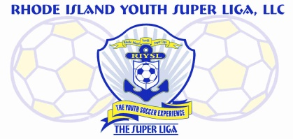
The Super Liga Newsletter is designed to keep you up to date with all that’s happening in the world of coaching and player development! Enjoy!
The Super Liga Newsletter is proudly designed and distributed by Giovanni Pacini, your Super Liga Director of Coaching Education.

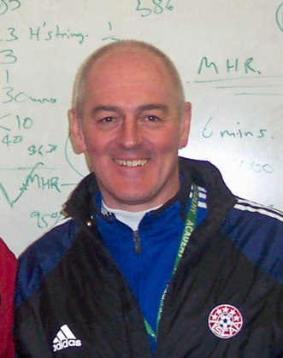
THE SUPER LIGA NEWSLETTER
Greetings and welcome to the First Edition of The Super Liga Newsletter! It is with great pleasure that I take this opportunity to introduce myself as the new Director of Coaching Education for The Super Liga. My name is Giovanni Pacini and I serve United Soccer Coaches as a member of the National Staff, National Goalkeeper Staff, and as State Director for RI, MA, and NH. I am also an East Region Staff Coach for USYS. I enjoyed a long career as a highly successful collegiate head coach and am now the Goalkeeper Coach at Regis College in Weston, MA. I am published and have appeared in coaching videos for both United Soccer Coaches and Play Sports TV.
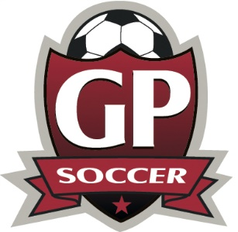
Listen to the GP Soccer Podcast! I am proud to share information about my now very successful podcast which features interviews with some of the foremost experts in the game. Each episode is created to be somewhat of a mini coaching education course where after tuning in, the listener is now that much more enlightened about a particular aspect of the game. Find it on Spotify, Pandora, iHeartRadio, Buzzsprout, Stitcher, Google Podcasts, Tune In, and Player FM!

The Super Liga is an official partner with United Soccer Coaches! Established in 1941, United Soccer Coaches is the largest organization of soccer coaches in the world. Our outstanding program of coaching education reaches every level from our Grassroots courses to the most advanced which includes goalkeeping and special topic courses. Learn more by visiting the United Soccer Coaches website at www.unitedsoccercoaches.org.
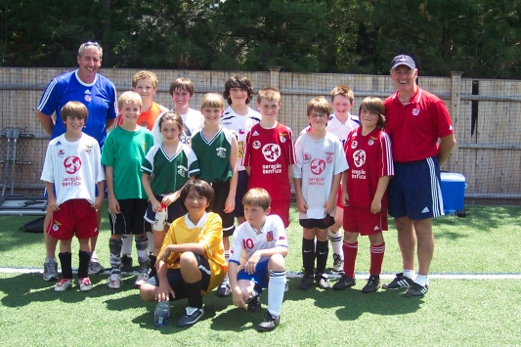
Across the country, we lose upwards to 70% of youth sports athletes often times by the time they reach middle school. The number one reason…it’s not fun. Research has shown that when coaching efficacy is improved via coaching education, coaches provide a far more enjoyable environment for the players, which increases retention. Your commitment to coaching education has a direct impact on the amount of kids who will stay in the game! Why? It’s more fun!

I am an expert contributor to the Soccer Parenting Association; an excellent source of information for parents whose children are involved in the game. Check it out!
HAVE FUN OUT THERE!

