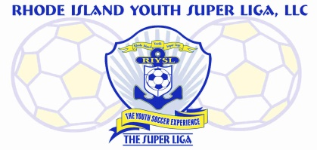
The Super Liga Newsletter is proudly designed and distributed by Giovanni Pacini, your Super Liga Director of Coaching Education.

The Super Liga Newsletter is designed to keep you up to date with all that’s happening in the world of coaching and player development! Enjoy!
THE SUPER LIGA NEWSLETTER #2
I am strongly encouraging all Super Liga coaches to tune into the GP Soccer Podcast where I interview Seth Taylor of Ianni Training. Seth and his partner Patrick Ianni have formulated an important approach and philosophy relative to how we develop players. It is a must listen for not only coaches, but parents as well. Find it on Spotify, Pandora, iHeartRadio, Buzzsprout, Stitcher, Google Podcasts, Tune In, and Player FM!

Super Liga coaches who have completed the United Soccer Coaches 11v11 course are encouraged to take the next step! The United Soccer Coaches National Diploma is being offered this June at Curry College in Milton, MA. The overall objective of the National Diploma is to acquaint the coach with the technical and tactical needs of players and provide an organized and progressive methodology of coaching those needs. Basic technical and tactical knowledge is the central theme of the course in a 7v7 model. The course includes sessions on the teaching process, psychological skills training and Laws of the Game.
- Time Commitment: 40 hours of directed learning, 1 hour field assessment
- Testing: Yes
- Prerequisites: None. United Soccer Coaches 11v11 / Pre-National Diploma or the U.S. Soccer ‘E’ License are strongly recommended.
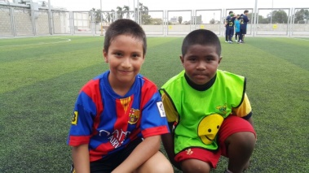
I will be formally encouraging all coaches at every age level to incorporate free play into their training regimens. Quite simply, at least once per week allow the players to organize their own games and just let them play. There is no better teacher of the game than the game itself. Your job is to insure their safety by keeping a watchful eye of the surroundings. Encourage them to make up some fun names for their teams and just sit back and enjoy kids just playing a game. The research is well established relative to the benefits of “street soccer” where the environment is devoid of coaching. Let ‘em play!
Are you training enough times per week? Are you aware of the “training to game ratio”? In order to effectively develop players, time on task is key. Assuming that the coach is certified and qualified, the team has the appropriate amount of field space to train, and all of the requisite equipment is available, then it is expected that the players train enough times per week.
A general guide would look like this-
Training to game ratio is vital in the player development scheme. All teams at every level should be playing just one game per week. An occasional participation in a tournament is ok but no more than twice per year should that take place.
U6-U8 2-3 times per week
U10-U12 3 times per week
U13 and up 4-5 times per week
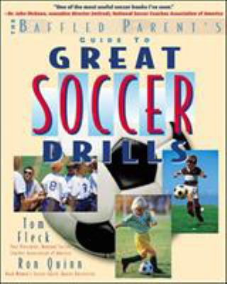

Here’s a great book of soccer activities if you’re coaching U6 and U8 players! It’s “The Baffled Parents Guide to Great Soccer Drills”! Find it easily on Amazon.

From Haim G. Ginott: a noted school teacher, child psychologist, and parent educator.
“I have come to the frightening conclusion that I am the decisive element in the classroom. It is my personal approach that creates the climate. It is my daily mood that makes the weather. As a teacher, I possess tremendous power to make a child’s life miserable or joyous. I can be a tool of torture or an instrument of inspiration; I can humiliate or humor, hurt or heal. In all situations, it is my response that decides whether a crisis is escalated or de-escalated, and a person is humanized or de-humanized. If we treat people as they are, we make them worse. If we treat people as they ought to be, we help them become what they are capable of becoming.”
HAVE FUN OUT THERE!

