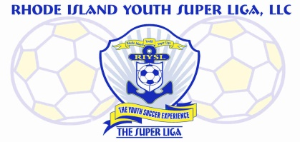
The Super Liga Newsletter is proudly designed and distributed by Giovanni Pacini, your Super Liga Director of Coaching Education.

The Super Liga Newsletter is designed to keep you up to date with all that’s happening in the world of coaching and player development! Enjoy!

THE SUPER LIGA NEWSLETTER #4
Be sure to be a part of the upcoming Super Liga Coaches Webinars as they will feature a few of the top soccer minds in the world. Webinars are scheduled to begin at 7 PM. The Super Liga DOCE Giovanni Pacini has arranged for the following soccer professionals to present.
April 2nd Arni Gudnason Head of Youth Development at IH Hafnarfjördur (FH) in Iceland.
April 9th Ian Barker and Dave Newbery DOCE and Director of eLearning for United Soccer Coaches
April 16th Dr. Bill Steffen Member of United Soccer Coaches National Staff and Goalkeeper Staff.
April 23rd Seth Taylor Co-Founder of Ianni Training
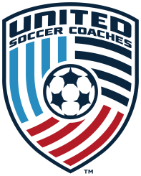
Did you know that United Soccer Coaches…
- Has over 1000 resources in its Online Resource Library
- Has a full catalogue of online courses in its eLearning program
- Has in-person courses for all levels of coaches
- Publishes The Journal covering all aspects of coaching soccer
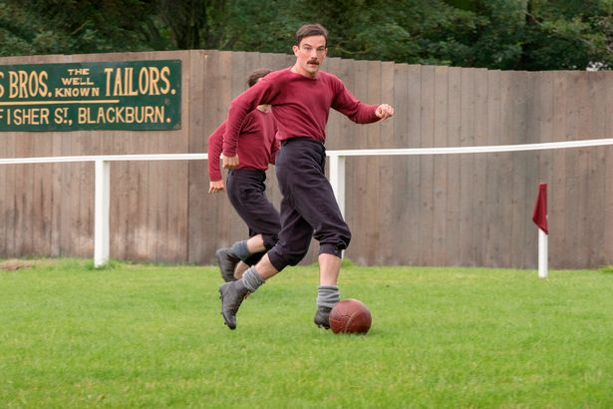
Check out the Netflix series called “The English Game”. The story tackles soccer’s class dynamics in the late 19th century, a pivotal period of the sport’s development. It is also a fascinating look at how the game was played in its earliest days and how some concepts of systems and style of play came to be. Key to the story is the class distinctions between the working class and upper class of people; a theme well known even today.

US Soccer has a new president in Cindy Parlow Cone. She takes over from Carlos Cordeiro who stepped down over the mishandling of the lawsuit filed by the USWNT against US Soccer. Parlow Cone scored 75 goals in 158 appearances for the U.S. winning the 1999 World Cup and two Olympic gold medals with the USWNT. She retired due to issues related to post-concussion syndrome. She was coach of the Portland Thorns during the NWSL inaugural season, leading the team to the league’s first title before stepping down to spend time with her family. Parlow was elected to the National Soccer Hall of Fame in 2018, and was voted in as USSF vice president in 2019. She will serve as president until the federation’s annual general meeting next February.

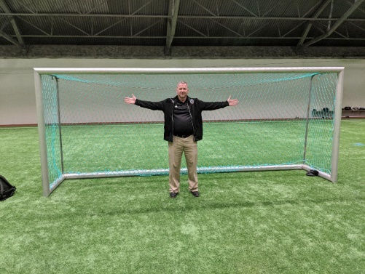
This is a picture of the goal that is used for all U6 and U8 games in Icelandic soccer. The goal is 6’ x 10’ and at these age levels, no goalkeepers are used. Why? The larger the goal, the higher the chances that a goal will be scored inciting a euphoria in the player that will feed the desire to want to shoot more hence contributing to the development of goal scoring tendencies. Refrain from using Pugg goals for these age groups.

You will note my continual emphasis on free play for all levels. As has been highlighted in past newsletters, the importance of allowing players to organize their own games and then play on their own has a significant impact on their development not only from a soccer standpoint, but from a human development one as well. The kids have to communicate, cooperate, and organize the games and then enjoy the freedom of just playing. The role of the coach is to supply the equipment and keep a watchful eye for the safety of the players. Let ‘em play!
As your Director of Coaching Education, I am at your service to answer any questions you may have. Given the size of The Super Liga, the ability to engage with folks face to face is indeed a challenge; especially now with the Coronavirus restrictions. But with technology, I am as close as can be through the use of e-mail, text, phone call, and webinar…if and only if you take advantage of it! My role is to serve you so that you can better serve your players. We’re in this together!

HAVE FUN OUT THERE!

