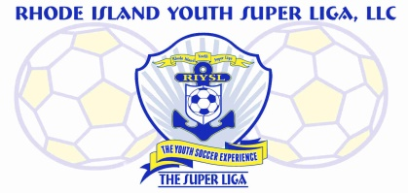
The Super Liga Newsletter is proudly designed and distributed by Giovanni Pacini, your Super Liga Director of Coaching Education.

The Super Liga Newsletter is designed to keep you up to date with all that’s happening in the world of coaching and player development! Enjoy!

THE SUPER LIGA NEWSLETTER #5
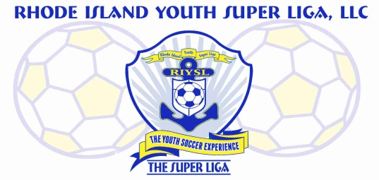

From: Giovanni Pacini
The Super Liga DOCE

Here are some recommended games for U10 Players:
1) Free Dribble- Everyone with a ball, use inside, outside, and sole of the foot. Have players dribble with speed (outside of foot), change direction, and perform moves. Coach calls out moves or changes in direction and sets the pace as the manipulator of the session; kids carry the ball towards someone and try a move. Version 2: As players get comfortable, coach can walk around and put passive pressure on players as they are performing dribbling tasks. This adds fun and interaction. Version 3: Make the game a knockout game in which players try to knock each other’s balls out of the grid while maintaining possession of their own. Note: You may wish to have them perform a skills task before re-entering such as 10 toe touches or juggling 5 times. You do not want players sitting out.
2) Shield-Steal- Half of players in the group have a ball and half do not. If you do not have a ball you need to steal one from someone who does. If ball goes out of bounds, person who touched it last does not get possession. You can teach players the technical points of shielding as a group at start of activity. Show technique with body sideways, arm providing protection, ball on outside foot, knees bent, turning as defender attacks, using feel to understand where defender is going. Fix technical shielding errors throughout this activity and make sure entire group knows how to properly shield.
3) Gates Passing- Same set up as previous game. However players are now paired up and must successfully pass the ball through the cones to their teammate to earn a point. Again, players try to accumulate as many points as possible in the time allotted. Similar to previous game, have them pass only with their left foot or right foot, or the outside of their foot.
4) 1 v 1 to lines- In a grid 10 x 20 l yards, players line up on opposite sides. The first player in each line alternates attacking the player opposite them. When the attacker dribbles over the line they score a point. If the defender wins the ball he or she can counter attack to the opposite line to also score a point. The players switch to the opposite line if a point is scored or the ball goes out of bounds. The coach rotates the lines so all players get to compete against each other. Version 2: Make the grid larger and make this a 2 v 2 or a 3 v 3 game.
5) 1 v 1 To Two Small Goals- Same grids as above except now there is a three foot goal in the middle of each line. Attackers try to score by passing the ball through the goal. Defenders can counter attack to the opposite goal if they win the ball. Players switch sides after a goal or the ball goes out of bounds. The coach rotates the lines so all players get to compete against each other.
6) 2 v 2 to Four Goals- Teams defend two goals and have the opportunity to score on the other two defending by the opposing team. The goals are positioned on each of the lines which create the square (15y x 15y). To provide a work-rest ratio, have one team of 2 on deck; they come on when a team gets scored on twice. Game is continuous, they must run on immediately.
7) 2 v 2 To Four Small Goals- To help develop more fine muscle skill use, in a 15 X 15 yard grid with a small goal (1y) on each line, the players defend two goals and attack the other two. The coach will set up as many grids as needed to accommodate the players. When the ball goes out of bounds it is freely in to play. Version 2: 3 v 3 in a 20 X 20 yard grid.
8) 4 v 4 End Zone Game- Teams comprised of 4-6 players depending on numbers and space. To score you must pass the ball to a teammate into the opponent’s end zone (created with discs). Players may not just stand in an end zone waiting for the ball; it must be a direct result of a true passing situation whether the ball is passed in for a player to run onto or he / she truly runs in to receive it. Stress recognizing opportunities and timing of passes.
9) Triangle Goal Game- Make a triangle (3y x 3y x 3y) with three cones in the center of a 20 x 20 playing grid. The sides of the triangle each serve as a goal mouth so teams can shoot at three different goals. Use 2 goalkeepers in the triangulated goal where they must try to defend the three openings. Two even teams play a normal soccer game, except they both can score on any of the three faces of the triangle for a point. The game is continuous and if a goalkeeper saves the ball he / she distributes to the other team. Version 2: Use two balls at the same time.
10) 4 v 4 To Four Small Goals- In a 30 X 35 yard grid, the same rules as 3 v 3. Players now look to maintain good attacking and defending shapes.

Every training session must end in a true game environment and under 10’s should play 7 v 7 (including a goalkeeper).
HAVE FUN OUT THERE!

