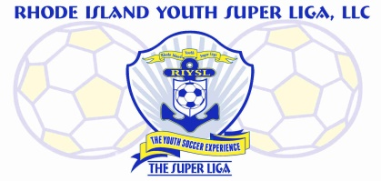
The Super Liga Newsletter is proudly designed and distributed by Giovanni Pacini, your Super Liga Director of Coaching Education.

The Super Liga Newsletter is designed to keep you up to date with all that’s happening in the world of coaching and player development! Enjoy!

THE SUPER LIGA NEWSLETTER #8
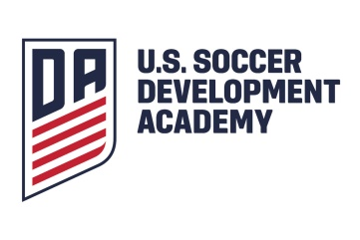
U.S. Soccer has formally announced that the Development Academy would be ceasing operations, ending the federation’s top youth league and leaving local clubs sorting out their next steps.
Simultaneously, Major League Soccer announced a new competition platform that's designed to provide year-round high-level matches for MLS club academy teams and non-MLS academy teams that were previously in the DA. There will be domestic and international competition, and they're also weighing future competition opportunities for girls.

Those members of our coaching community who are involved with U9 and U10’s are reminded that the formal use of the build out line both in training and in matches is expected. We as American soccer coaches must remain committed to development first and the need for our players to master the skill of building out of the back is a must. Later in their development can we then introduce situations where a more direct approach is utilized when coming out of the back.

Have you taken advantage of United Soccer Coaches on-line Goalkeeper Level 1 Diploma course? Once players have graduated from the 4v4 level to 7v7, then goalkeepers are utilized, hence the need for coaches to have a basic understanding of the position. Goalkeepers reaching the 9v9 and beyond levels require coaches to have an even higher understanding of the position and training methods; hence, the need for the United Soccer Coaches Goalkeeper Level 2 and Level 3.
At the grassroots level, every player should participate in at least 50% of every game. This is an expectation of US Soccer. The game is where players ultimately learn most effectively.

From U7 on, players can be encouraged to think about the 4 moments of the game- 1. We have the ball; attacking. 2. We’ve lost the ball. 3. We’re defending. 4. We’ve won the ball back; counter. Through the use of key words and guided questions, you as the coach can facilitate this. Here are some examples.-
Attacking
Key Words – “Open; let’s get open.”
Guided question – “Say Johnny, where can you go to get open?”
Concept – Players looking to find spaces (openings) where they may potentially receive the ball.
We’ve lost the ball.
Key Words – “Behind the ball.” “Pressure the ball.”
Guided question – “Billy, are you close enough to pressure the ball?”
Concept – Recovering so as to position players behind the ball in defense.
Defending
Key Words – “Tighten up.”
Guided question - “Mary, where can you go to stop an attacker?” “Should we be spread out or be tighter in front of the goal?”
Concept – Creating a more compact shape whilst defending.
We’ve won the ball back.
Key Words – “Counter.” “Let’s push the ball up quickly.”
Guided question – “Christine, when you dribble up field with no pressure, should you go slow or fast?”
Concept – Moving from a defensive shape to an attacking one as quickly as possible while out pacing the (now) defensive team.

HAVE FUN OUT THERE!

